Implementation Diagrams Of The System

Component Diagram
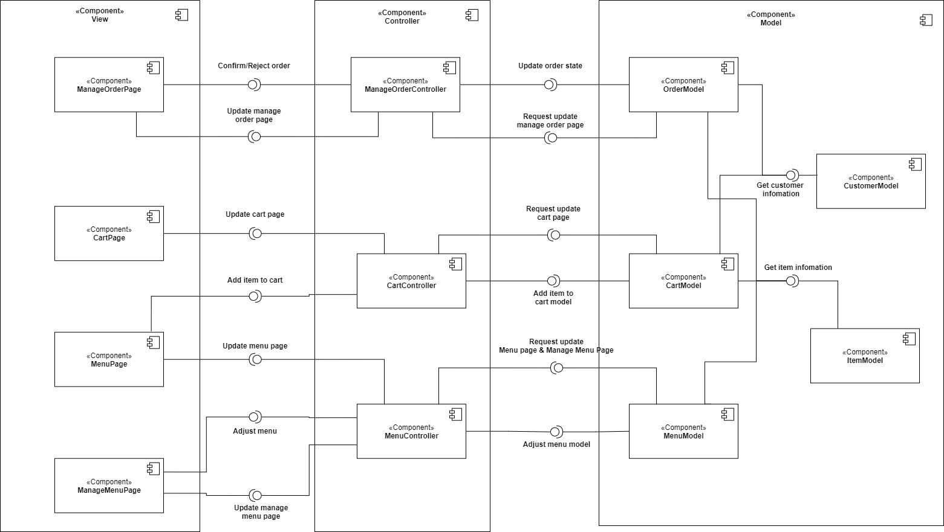
Figure 15: Component Diagram - Food Ordering, Menu Management

Short Description : The component diagram is for 3 features: Food Ordering, Order Management and Menu Management. This diagram based on the MVC Architecture Pattern. There are 12 components which are divided into 3 main big components:
      - View: ManageOrderPage, CartPage, MenuPage, ManageMenuPage. These components present the data to user and send user’s interactions to Controller component in order to manipulate database.
      - Controller: ManageOrderController, CartController, MenuController. These components

receive user’s interactions from View component and update Model component according to that.
      - Model: OrderModel, CartModel, MenuModel, CustomerModel, ItemModel. These compo- nents directly interact with the database.

Package Diagram
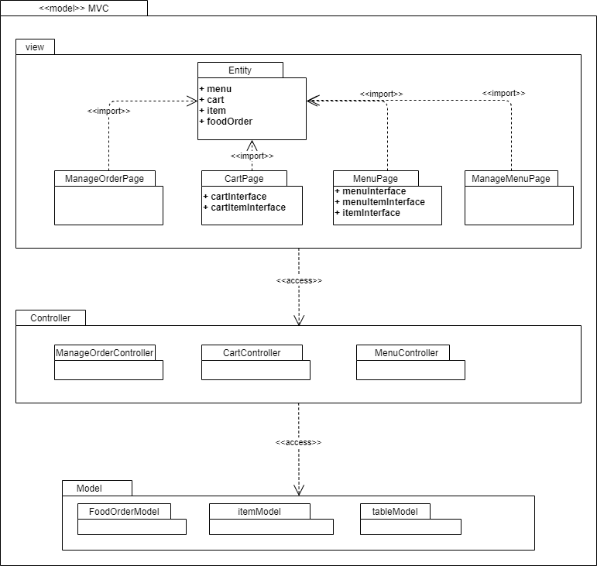
Figure 16: Package Diagram - Food Ordering, Menu Management

Short Description : The Package diagram has 3 packages: View, Controller and Model. Package View has 5 packages. Entity package consists of classes which is corresponding to entity.

